**Logistic regression**

**Comfort**

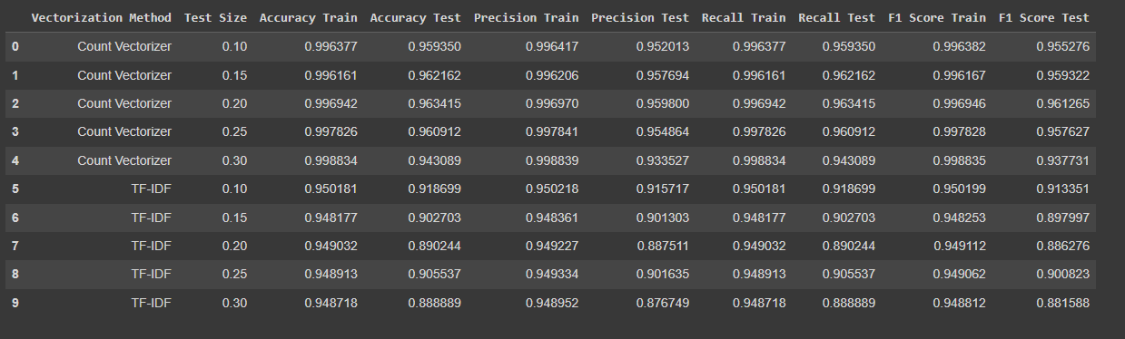

**Naive Bayes**

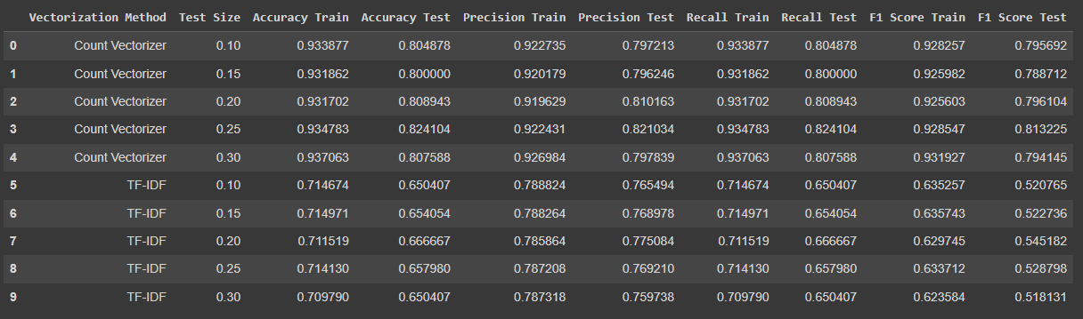

**SVM**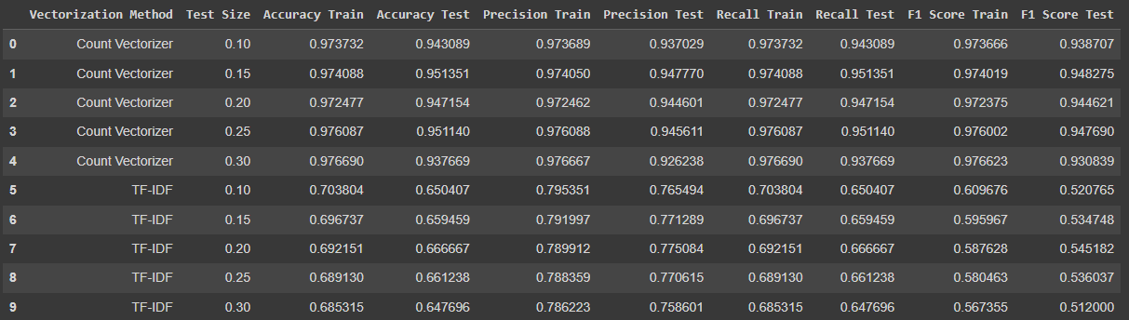

**DESIGN**

**Logistic regression**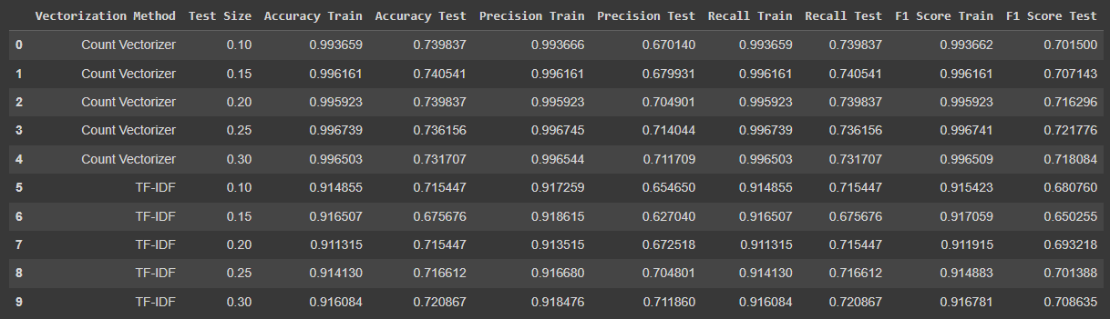

**Naive Bayes**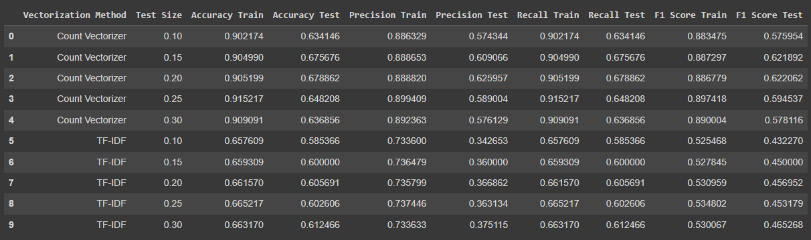

**SVM**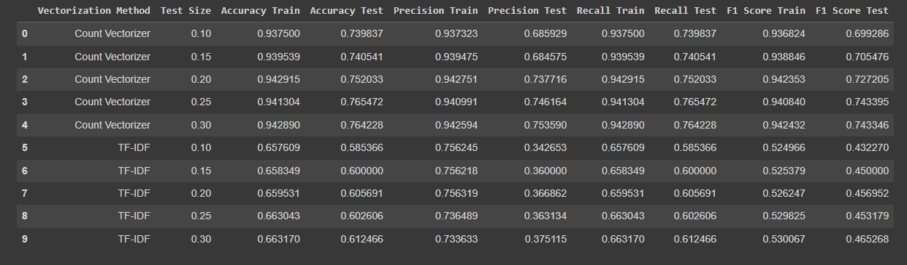

**SENTIMENT**

